Assignment 1
For each group, distribute the features from your project among yourselves based on the approved project idea.
Q1. Write down the functional and non-functional requirements for your system based on those features.
Q2. Draw a class diagram based on your whole system for those features/modules to be implemented.
Q3: Why is MVC architecture the best fit for your project? If you were to be asked to choose an alternative architecture, which one would you choose and why?
Question 1

Functional Requirements (FRs)
1. The system shall record every manual edit, pivot, and AI generation in a chronologically ordered version-control log.
2. The system shall provide a global search bar to find specific decisions, document text, or competitor data across all past versions and rooms.
3. The system shall auto-generate Go-To-Market (GTM) strategies, acquisition channels, and actionable launch checklists tailored to the detected audience.
4. The system shall automatically generate a Problem Statement, Proposed Solution, Unique Value Proposition, and Business Model based on the stored knowledge base.
5. The system shall auto-discover real-world competitors and generate a comparison matrix detailing their strengths, weaknesses, and pricing.

Non-Functional Requirements (NFRs)

1. Progressive rendering must display the initial AI output within 5 seconds of an idea submission.
2. The system architecture must support horizontal scaling to handle concurrent AI processing requests.
3. All client-server communication must occur exclusively over HTTPS.
4. Business data and user passwords must be encrypted at rest in the database.
5. The system must maintain a 99.9% uptime, excluding scheduled maintenance windows.

Question 2
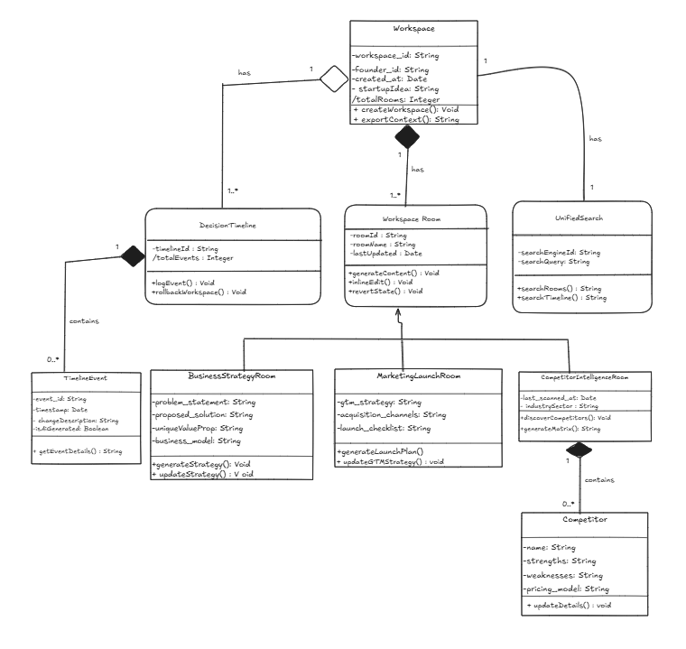

Class Diagram Link: https://excalidraw.com/#json=G_dYFTTXX1bg8PB9SFOUA,fx3HWE8KJ66ZOJlRlKnYzQ

Question 3

Why MVC is the Best Fit for Buniyadi
The Model-View-Controller (MVC) architecture is ideal for this project because it establishes an unbreakable, one-way data flow that prevents logic entanglement.
- Separation of Concerns: It strictly limits the React frontend (View) to rendering UI and managing local state, ensuring it never contains business logic or calls the database.
- Maintainability: Controllers are kept extremely thin (limited to 15 lines), acting only as coordinators that extract requests, call service functions, and return responses.
- Database Integrity: Models and Repositories are the only layers permitted to communicate with the database. This ensures that complex business logic inside the Service layer does not become coupled with Mongoose queries.
- Standardization: It keeps the codebase scalable and predictable, making it easy for new developers to understand exactly where a file belongs.
The Best Alternative Architecture: Microservices
If we need to choose an alternative, a Microservices Architecture would be the most logical alternative.
- Why: The Buniyadi project already implements elements of this pattern by utilizing FastAPI as a dedicated, separate AI microservice to handle all natural language processing and LLM communication.
- If the application scales significantly, splitting the core MERN backend into independent domain services (a "Workspace Generation Service", a "Version Control/Timeline Service", and an "Authentication Service") would allow the team to scale heavily utilized features independently. For instance, the AI context generation and timeline state saving mechanisms will likely consume vastly different server resources compared to user authentication, making independent horizontal scaling highly beneficial.

